**Unit 11.2 : Program Design**

Weekly_Test 1 (30 Jan 2023 to 6 Feb 2023)

1. Draw a structure chart to input the radius of a sphere, calculate output, and output either the volume or the surface area.

[6 Marks].

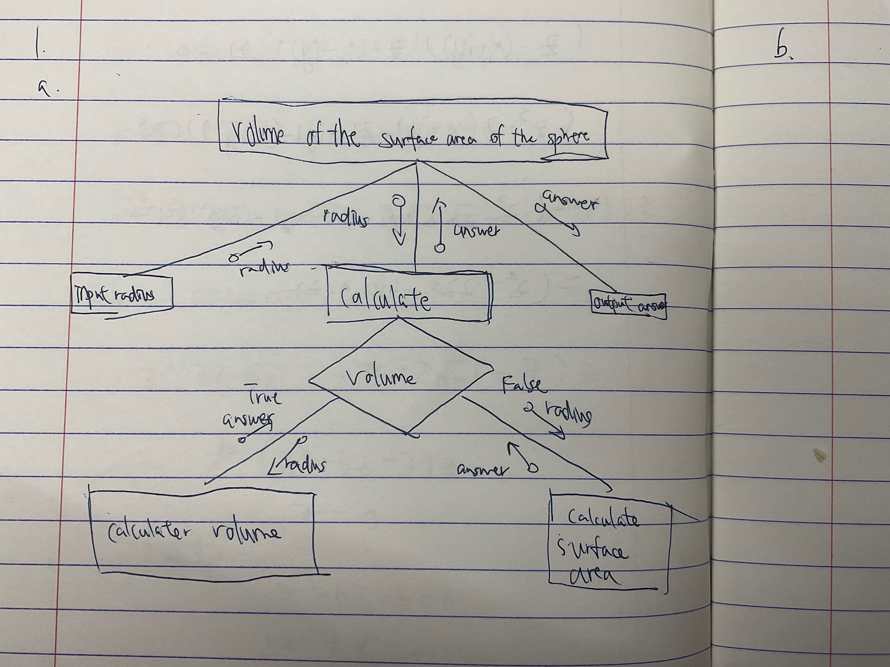

1. From the structure chart that you have drawn in Q1, write a Pseudo Code of a function to calculate the volume of a sphere, and also write another Pseudo code of a function to calculate the surface area of a sphere. You would also need to declare the variable and constants used in your Pseudo Code.

[4 Marks]

DECLARE radius:INTEGER

CONSTANT pi : 3.14

OUTPUT (‘Please enter the radius of the sphere’)

INPUT radius

WHILE radius > 0 DO

INPUT (‘Please enter a positive number’)

OUTPUT radius

ENDWHILE

Calculate surface area = pi * radius *radius

Calculate volume = ¾ * pi * radius * radius * radius

OUTPUT ‘the surface area is’,surface area

OUTPUT ‘the volume of the sphere is’,volume